archie yarr, AYARR200@caledonian.ac.uk

Use Case Diagram, Forms, Scenarios, Activity Diagrams are enclosed

WPD2 Design Doc

All deliverables related to UML

Contents

UML For WPD2 4

Use Case Diagr 4

Use Case Forms and attached Scenarios 5

Create Planner Scenarios 5

Add goals to planner Scenarios 6

Edit Goals in Planner Scenarios 7

Remove Goals from Planner Scenarios 8

Share Planner Scenarios 9

View Shared Link Scenarios 10

Login Scenarios 11

Logout Scenarios 12

Register Scenarios 13

Activity Diagrams 15

REMEMBER TO EDIT THE FORMS BASED ON ACTIVITY DIAGRAMS, REMOVE CREATE PLANNER FORMS AND TALK ABOUT THE REMOVAL

# UML For WPD2

## Use Case Diagram

## Use Case Forms and attached Scenarios

|  |  |
| --- | --- |
| Use Case Name | Create Planner |
| Description | Allows users to create an activity planner to track fitness activities including day of training, type of training, duration of training, week of training (i.e. week 1, week 2 etc), date of training |
| Actors | User |
| Pre-Conditions | The user has logged in with a registered account |
| Trigger | User selects the create planner option |
| Main Flow of Events | 1. User navigates to the create planner section 2. User clicks on create planner 3. User makes the required entries of the planners required details 4. User confirms and saves the creation of their planner |
| Alternative Flow of Events | See “Create Planner Scenarios” |
| Post-Condition | The user has created a planner |
| Issues | N/A |

### Create Planner Scenarios

Main Scenario

1. User navigates to the create planner section
2. User clicks on create planner
3. User makes the required entries of the planners required details **[A1]**
4. User confirms and saves the creation of their planner

Alternative Scenario

1. User navigates to the create planner section
2. User clicks on create planner
3. User makes the required entries of the planners required details

**[A1]** The entries the user made are not permissible entries

* The system gives the user the appropriate error message
* The user enters entries of a correct type as listed in the error message

1. User confirms and saves the creation of their planner

|  |  |
| --- | --- |
| Use Case Name | Add Goals to Planner |
| Description | Allows users to add goals to a planner, for example, a user would be able to add ‘running’ to week in the planner |
| Actors | User |
| Pre-Conditions | The user has logged in with a registered account in which they have created a planner |
| Trigger | User selects the add goal to planner option |
| Main Flow of Events | 1. User opens their planner 2. User selects to add goals to their planner 3. User makes the required changes 4. User confirms and saves the addition of the goals |
| Alternative Flow of Events | See “Add goals to planner Scenarios” |
| Post-Condition | The user has added a goal to their pre-existing planner |
| Issues | N/A |

### Add goals to planner Scenarios

Main Scenario

1. User opens their planner
2. User selects to add goals to their planner
3. User makes the required changes**[A1]**
4. User confirms and saves the addition of the goals

Alternative Scenario

1. User opens their planner
2. User selects to add goals to their planner
3. User makes the required changes

**[A1]** User attempts to exit the planner without saving

* The system gives the user a warning message as changes will not be saved
* User does not want to save the addition

1. User confirms and exits without saving

|  |  |
| --- | --- |
| Use Case Name | Edit Goals in Planner |
| Description | Allows users to edit a pre-existing goal that is contained in a planner, for example, a user would be able to edit ‘running’ to ‘HIT circuit’ in a planner |
| Actors | User |
| Pre-Conditions | The user has logged in with a registered account and has a planner containing goals |
| Trigger | The selects the edit goal option |
| Main Flow of Events | 1. User opens their planner 2. User selects the goal they wish to edit 3. User makes the necessary changes to their goal 4. User confirms and saves the edit |
| Alternative Flow of Events | See “Edit Goals in Planner Scenarios” |
| Post-Condition | The user has saved and confirmed the changes to their goals contained in the planner |
| Issues | N/A |

### Edit Goals in Planner Scenarios

Main Scenario

1. User opens their planner
2. User selects the goal they wish to edit **[A1]**
3. User makes the necessary changes to their goal
4. User confirms and saves the edit **[A2]**

Alternative Scenario

1. User opens their planner
2. User selects the goal they wish to edit

**[A1]** There is no goal available to edit

* The user proceeds to the add goal function
* The user adds the goal to the planner
* The user makes the required changes

1. User confirms and saves the edit

**[A2]** The user does not wish to save the edit they made

* The user exits without saving
* The system gives the user a warning message
* The user ignores this and exits without saving

|  |  |
| --- | --- |
| Use Case Name | Remove Goals from Planner |
| Description | Allows users to remove goals from a planner, for example a user will be able to remove ‘running’ from the planner |
| Actors | User |
| Pre-Conditions | The user has logged in with a registered account and they have a planner with at least one created goal |
| Trigger | The user selects the remove goal option |
| Main Flow of Events | 1. User opens their planner 2. User selects to remove goals from their planner 3. User removes the required goals 4. User confirms and saves the removal |
| Alternative Flow of Events | See “Remove Goals from Planner Scenarios” |
| Post-Condition | The user has removed a goal from the planner |
| Issues | N/A |

### Remove Goals from Planner Scenarios

Main Scenario

1. **[A1]** User opens their planner
2. User selects to remove goals from their planner
3. User removes the required goals
4. **[A2]** User confirms and saves the removal

Alternative Scenario

**[A1]** The user attempts to open their planner

* The user is met with a “500” code error message
* The user refreshes the page to remedy the internal server error
* The user is able to access the server

1. User opens their planner
2. User selects to remove goals from their planner
3. User removes the required goals

**[A2]** The user does not wish to save the removal they made

* The user exits without saving
* The system gives the user a warning message
* The user ignores this and exits without saving

|  |  |
| --- | --- |
| Use Case Name | Share Planner |
| Description | This allows the user to create a copyable link of their planner to share with other users or potential users, if a user or actor has the link they are assumed to have ‘view only’ access to the planner and can view it but not make changes. |
| Actors | User |
| Pre-Conditions | The user has logged in with a registered account and has a created planner |
| Trigger | The user selects the share planner option |
| Main Flow of Events | 1. User navigates to their planner 2. User selects the create planner share link 3. User receives the link 4. User copies link 5. User exits |
| Alternative Flow of Events | See “Share Planner Scenarios” |
| Post-Condition | User has been given the opportunity to save the shareable link |
| Issues | N/A |

### Share Planner Scenarios

Main Scenario

1. User navigates to their planner
2. User selects the create planner share link **[A1]**
3. User receives the link
4. User copies link
5. User exits

Alternative Scenarios

1. User navigates to their planner
2. User selects the create planner share link

**[A1]** The create link option does not return a link

* The user receives an appropriate error message
* The user logs out of their account and re-attempts
* The user is able to use the link function

1. User receives the link
2. User copies link
3. User exits

|  |  |
| --- | --- |
| Use Case Name | View shared link |
| Description | Allows users with a shared link to view another user’s planner in view only mode by entering the link into a browser. They can’t make changes to the viewed planner. |
| Actors | User |
| Pre-Conditions | The user has a link |
| Trigger | The user copies the link into a browser |
| Main Flow of Events | 1. User copies link into browser 2. User views the planner and any contained goals 3. User exits by closing the window |
| Alternative Flow of Events | See “View Shared Link Scenarios” |
| Post-Condition | User has been able to access the view only planner |
| Issues | N/A |

### View Shared Link Scenarios

Main Scenario

1. User copies link into browser **[A1]**
2. User views the planner and any contained goals
3. User exits by closing the window

Alternative Scenarios

1. User copies link into browser

**[A1]** The link is no longer functional, and the user is met with a 404 error message

* The user requests a new version of the link from the person they received it from
* The user enters the link into the browser

1. User views the planner and any contained goals
2. User exits by closing the window

|  |  |
| --- | --- |
| Use Case Name | Login |
| Description | Allows a user to login with a registered account |
| Actors | User |
| Pre-Conditions | User has registered an account and has their login details |
| Trigger | User selects the login option |
| Main Flow of Events | 1. User enters site 2. User selects the login option 3. User enters their username and password 4. Users inputs are validated 5. User is logged in |
| Alternative Flow of Events | See “login Scenarios” |
| Post-Condition | User has been logged in or has failed verification |
| Issues | N/A |

### Login Scenarios

Main Scenario

1. User enters site
2. User selects the login option
3. User enters their username and password
4. **[A1] [A2]** Users inputs are validated
5. User is logged in

Alternative Scenario

1. User enters site
2. User selects the login option
3. User enters their username and password

**[A1]** The users’ details are not verified, they are prompted to reattempt entry

* The user corrects a spelling error
* The user enters the details

**[A2]** The users’ details are not verified; they are prompted to register these details as neither match a stored data set

* The user follows the registration process
* The user re-attempts the input at login page

1. Users inputs are validated
2. User is logged in

|  |  |
| --- | --- |
| Use Case Name | Logout |
| Description | Allows users to logout of their account |
| Actors | User |
| Pre-Conditions | User has logged in with a registered account |
| Trigger | User selects the logout option |
| Main Flow of Events | 1. User selects the logout option 2. User confirms their selection 3. User is logged out |
| Alternative Flow of Events | See “logout Scenarios” |
| Post-Condition | User is logged out |
| Issues | N/A |

### Logout Scenarios

Main Scenario

1. User selects the logout option**[A1]**
2. **[A2]** User confirms their selection
3. User is logged out

Alternative Scenario

1. User selects the logout option

**[A1]** User does not want to confirm their selection

* User selects the do not log out option
* Use remains logged in.

1. User selects the logout option

**[A2]** The user receives a “500” code error message

* The user refreshes the page
* The user is connected to the server
* The user reselects the logout option

1. User confirms their selection
2. User is logged out

|  |  |
| --- | --- |
| Use Case Name | Register |
| Description | Allows a user to register an account with the system and set login details to allow them to access the systems full feature set |
| Actors | User |
| Pre-Conditions | User has a connection to the server |
| Trigger | User selects the register option |
| Main Flow of Events | 1. User enters the site 2. User selects register 3. User enters their registration details 4. User selects create account 5. System verifies user input 6. User verifies their selections 7. Account is created |
| Alternative Flow of Events | See “Register Scenarios” |
| Post-Condition | An account has been created for the user |
| Issues | N/A |

### Register Scenarios

Main Scenario

1. User enters the site
2. User selects register
3. User enters their registration details
4. User selects create account
5. System verifies user input**[A1] [A2][A3]**
6. User verifies their selections
7. Account is created

Alternative Scenario

1. User enters the site
2. User selects register
3. User enters their registration details
4. User selects create account
5. System verifies user input

**[A1]** The users’ input is already stored in the database

* The system notifies the user that their account exists and prompts the login function
* The user wishes to create a different account
* The user enters new details
* The user selects create account
* The system verifies the user input

1. User verifies their selections
2. Account is created
3. User enters the site
4. User selects register
5. User enters their registration details
6. User selects create account
7. System Verifies user input

**[A2]** The user is prompted that their details already exist as an account

* The user goes to the login section
* The user enters their details
* The user is logged in

## Activity Diagrams

### Create Planner Activity Diagram

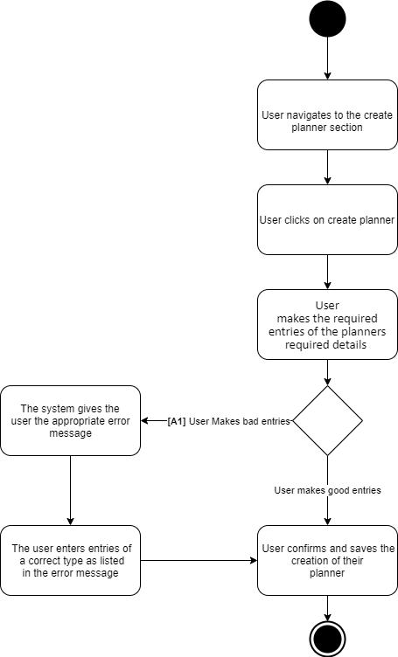

### Edit Goals in Planner Activity Diagram

### Remove Goals from Planner Activity Diagram

### Share Planner Activity Diagram

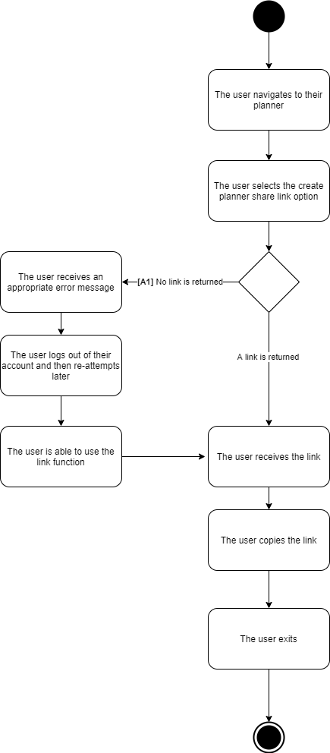

### View Shared Link Activity Diagram

### Login Activity Diagram

### Logout Activity Diagram

### Register Activity Diagram

### Notes on Activity Diagrams and Iterations of The UML created

I created a “Create planner” use case considering multiple planners in the design, upon further consideration I decided against this and decided to remove it from the use case diagram, to illustrate the iterations I have my first paper copy photographed, my first digital iteration and my final product together. Similar processes were undertaken with each activity diagram with at least 2 iterations existing for some.

**Paper Iteration of Use Case**

**First digital Use Case Iteration**

**Final Digital Use Case Iteration**

